**CC DevOps – Lab 3 (20 Marks) – Jagdev Singh**

**(August 2022 Batch for Certification in Full Stack Software Development in Java)**

1. **Details and Snapshot of Steps followed for this Lab**

**VPC ID IPv4 CIDR**

vpc-00ff5f4881b43b58f 10.0.0.0/16

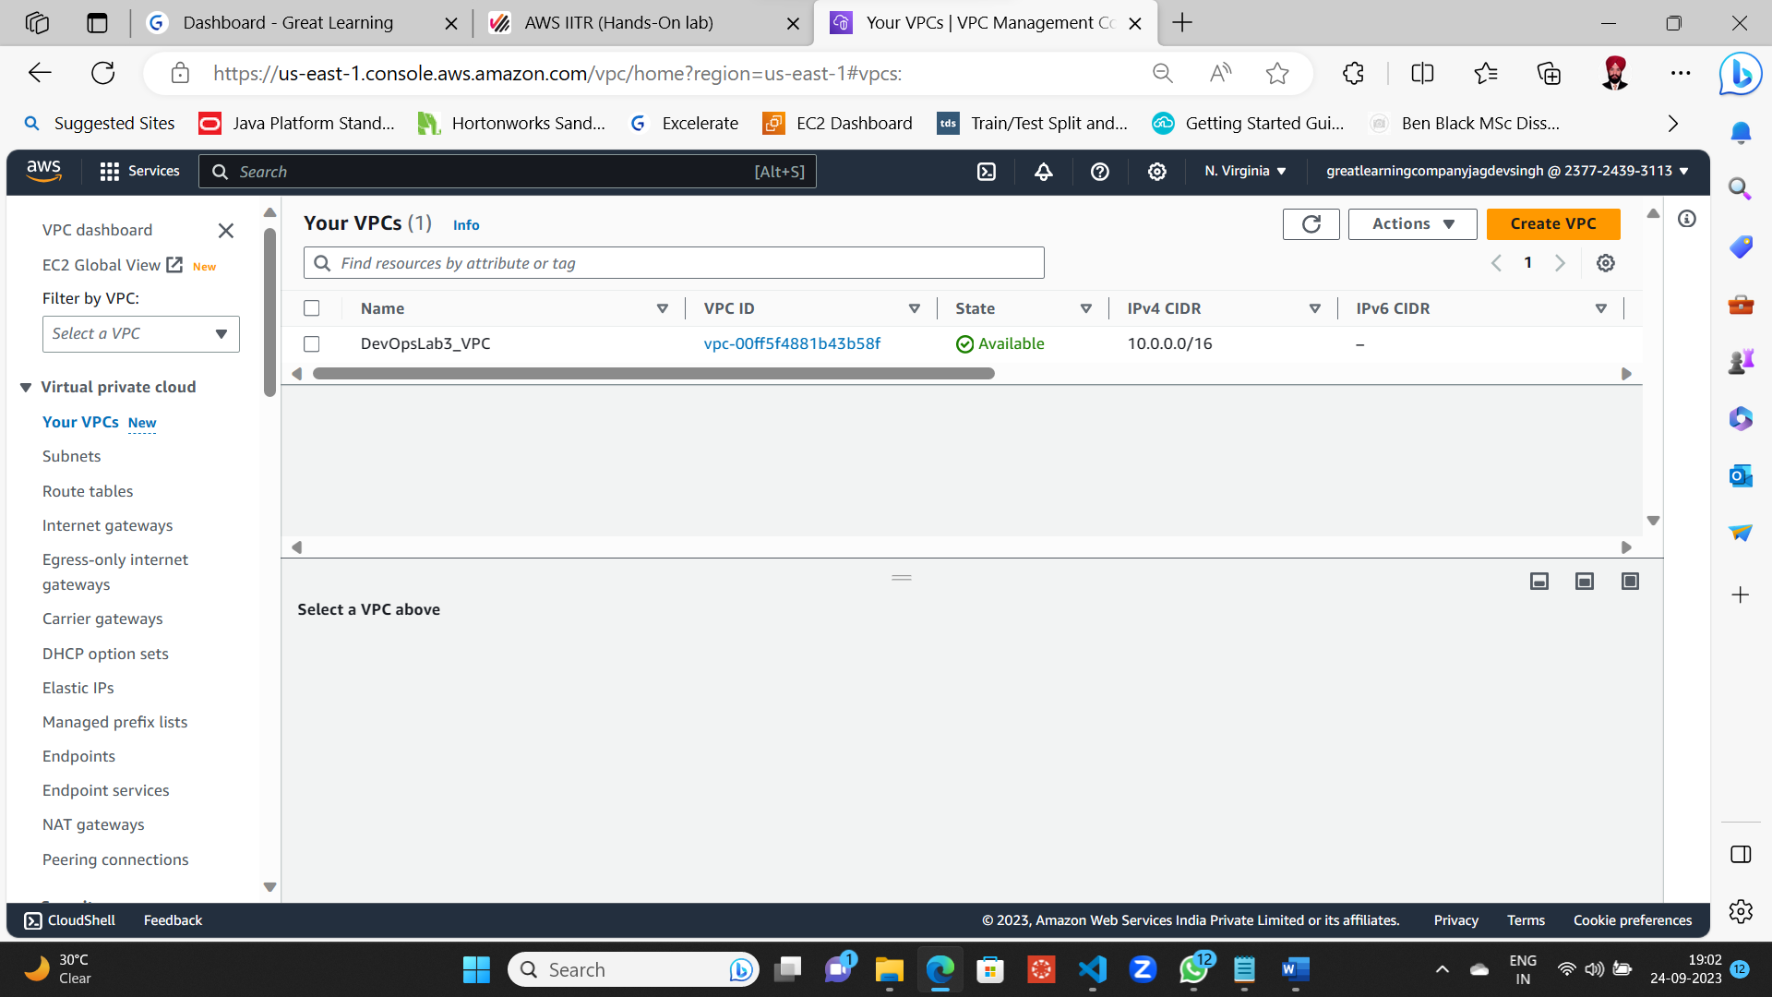

Subnets under VPC 2

**Subnet 1**

Subnet ID subnet-05d5db5e19cdb2fab

IPv4 CIDR 10.0.0.0/20

Availability Zone us-east-1a

**Subnet 2**

Subnet ID subnet-0a2ad0a5181acf443

IPv4 CIDR 10.0.16.0/20

Availability Zone us-east-1b

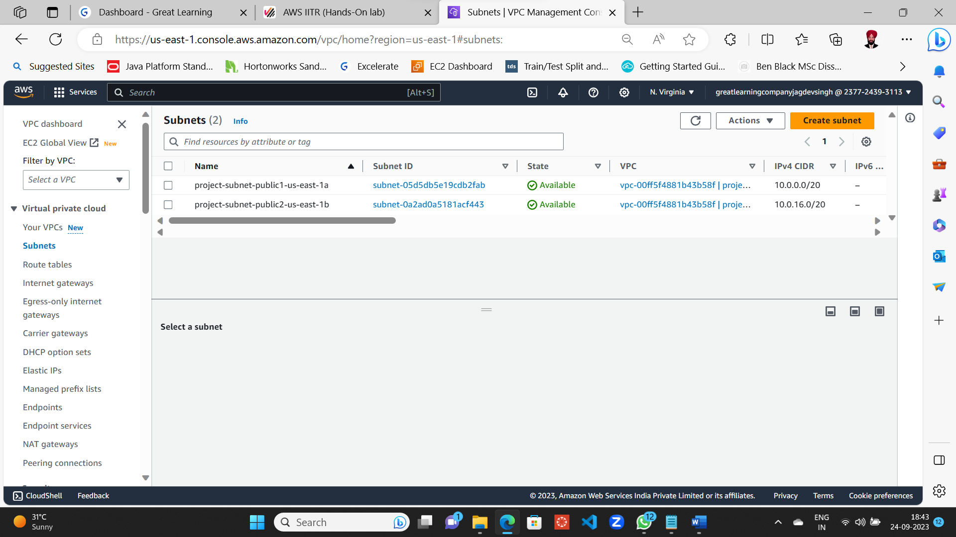

Subnets under VPC 2 with VPC ID vpc-00ff5f4881b43b58f

CF1.json file modified at the said lines 18, 23 and 28 as per instructions

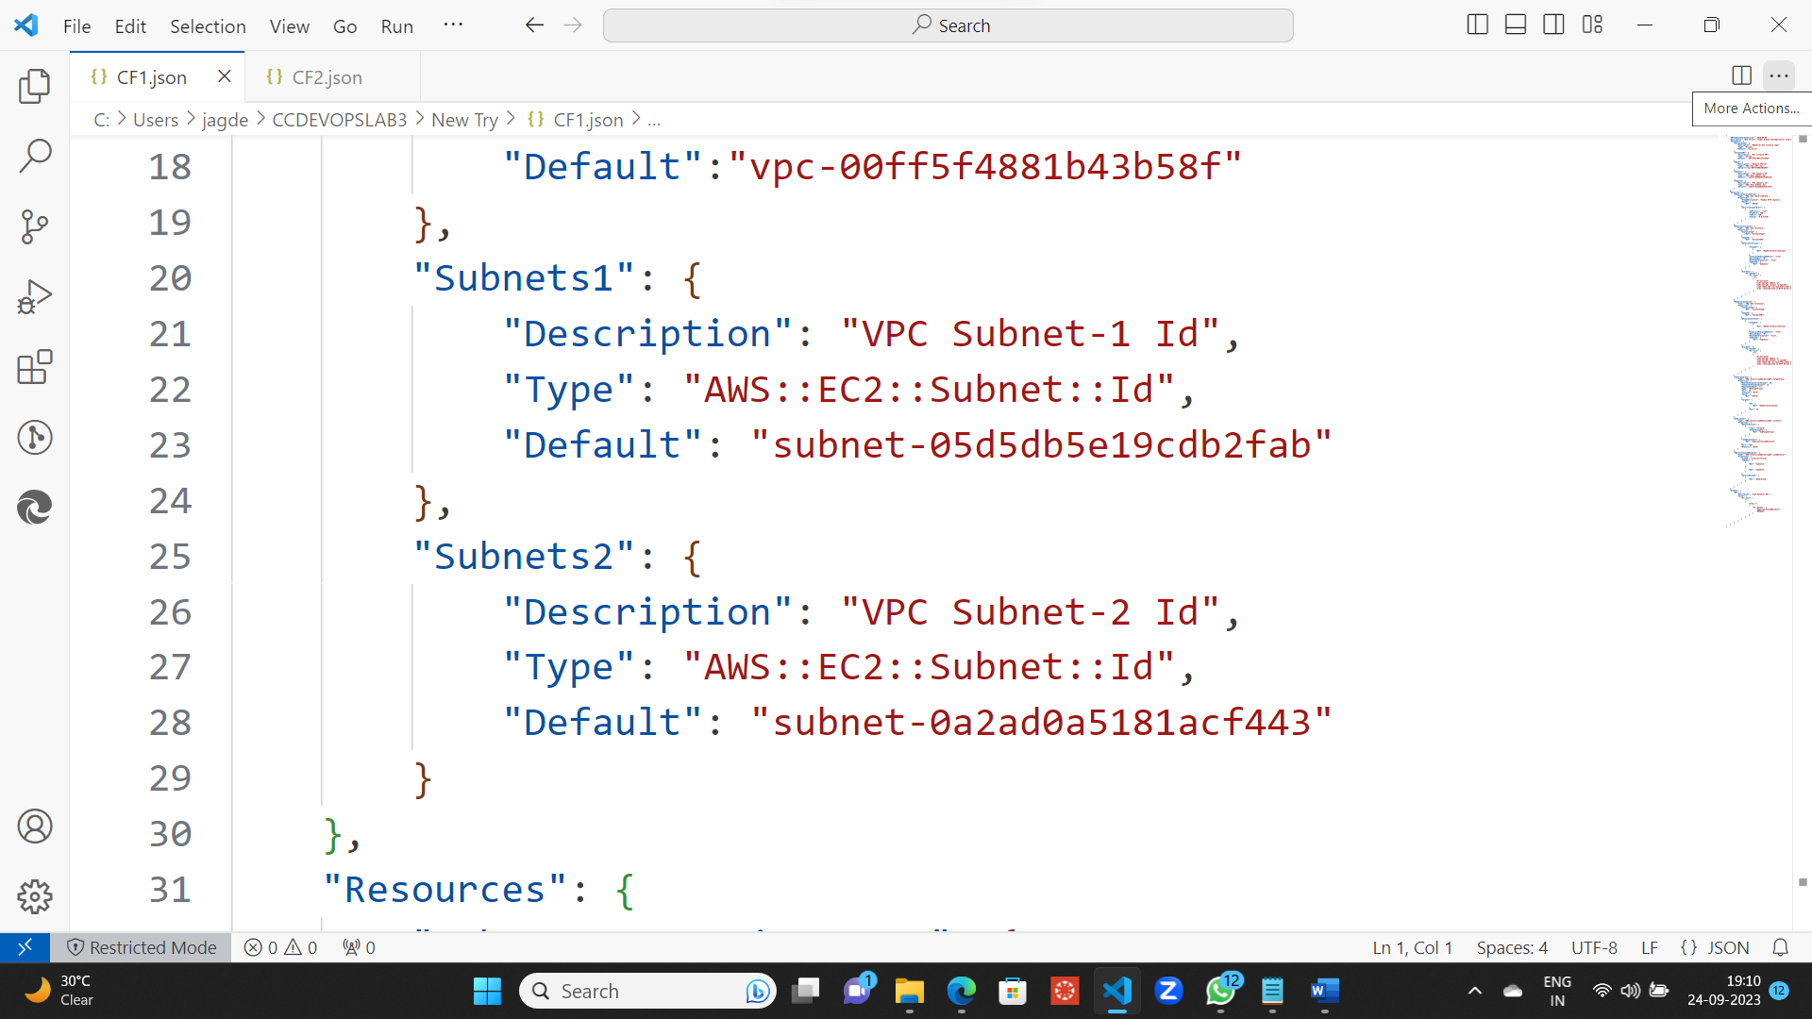

Cloud Formation File 1 (CF1.json)

CF2.json file modified at the said lines 18, 23 and 28 as per instructions

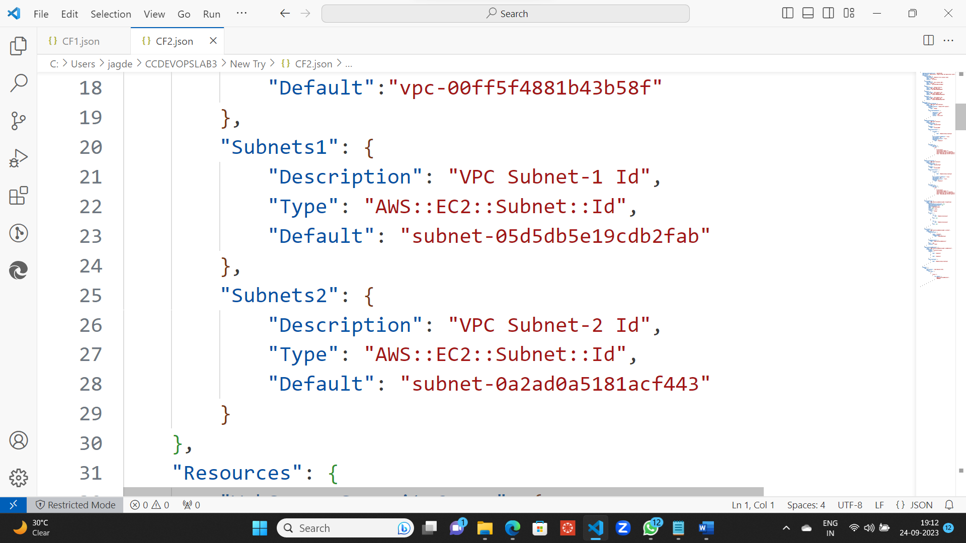

Cloud Formation File 2 (CF2.json)

Both these files saved and closed using VS Code Editor

Opening the AWS Clous Shell for uploading both these Cloud Formation Files

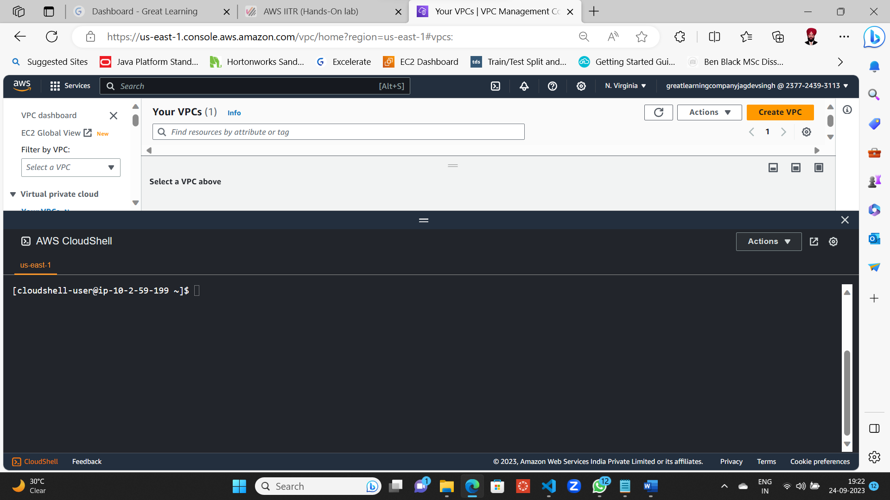

Cloud Formation File 1 (CF1.json) Uploading

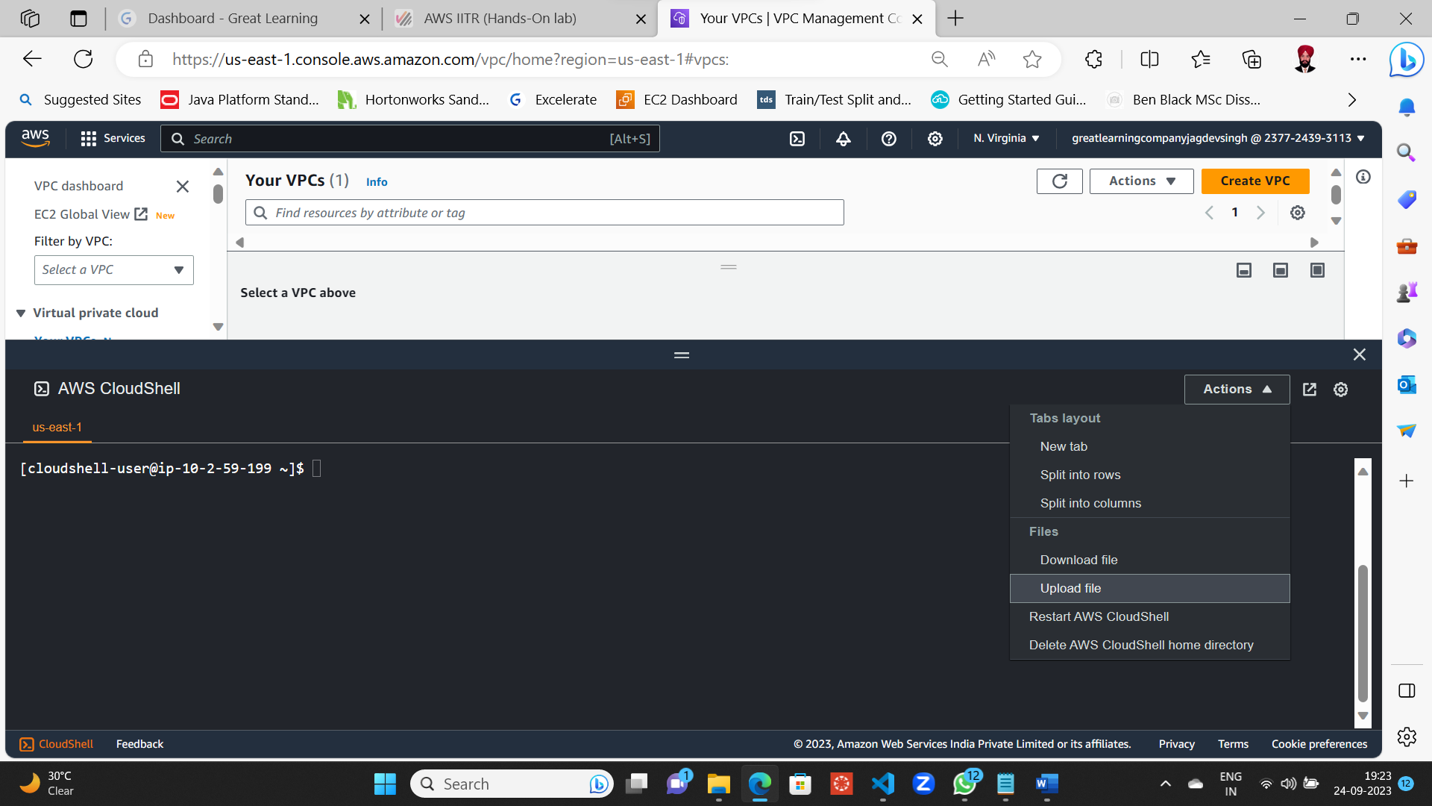

Uploading on AWS Cloud Shell terminal

File 1 Uploading

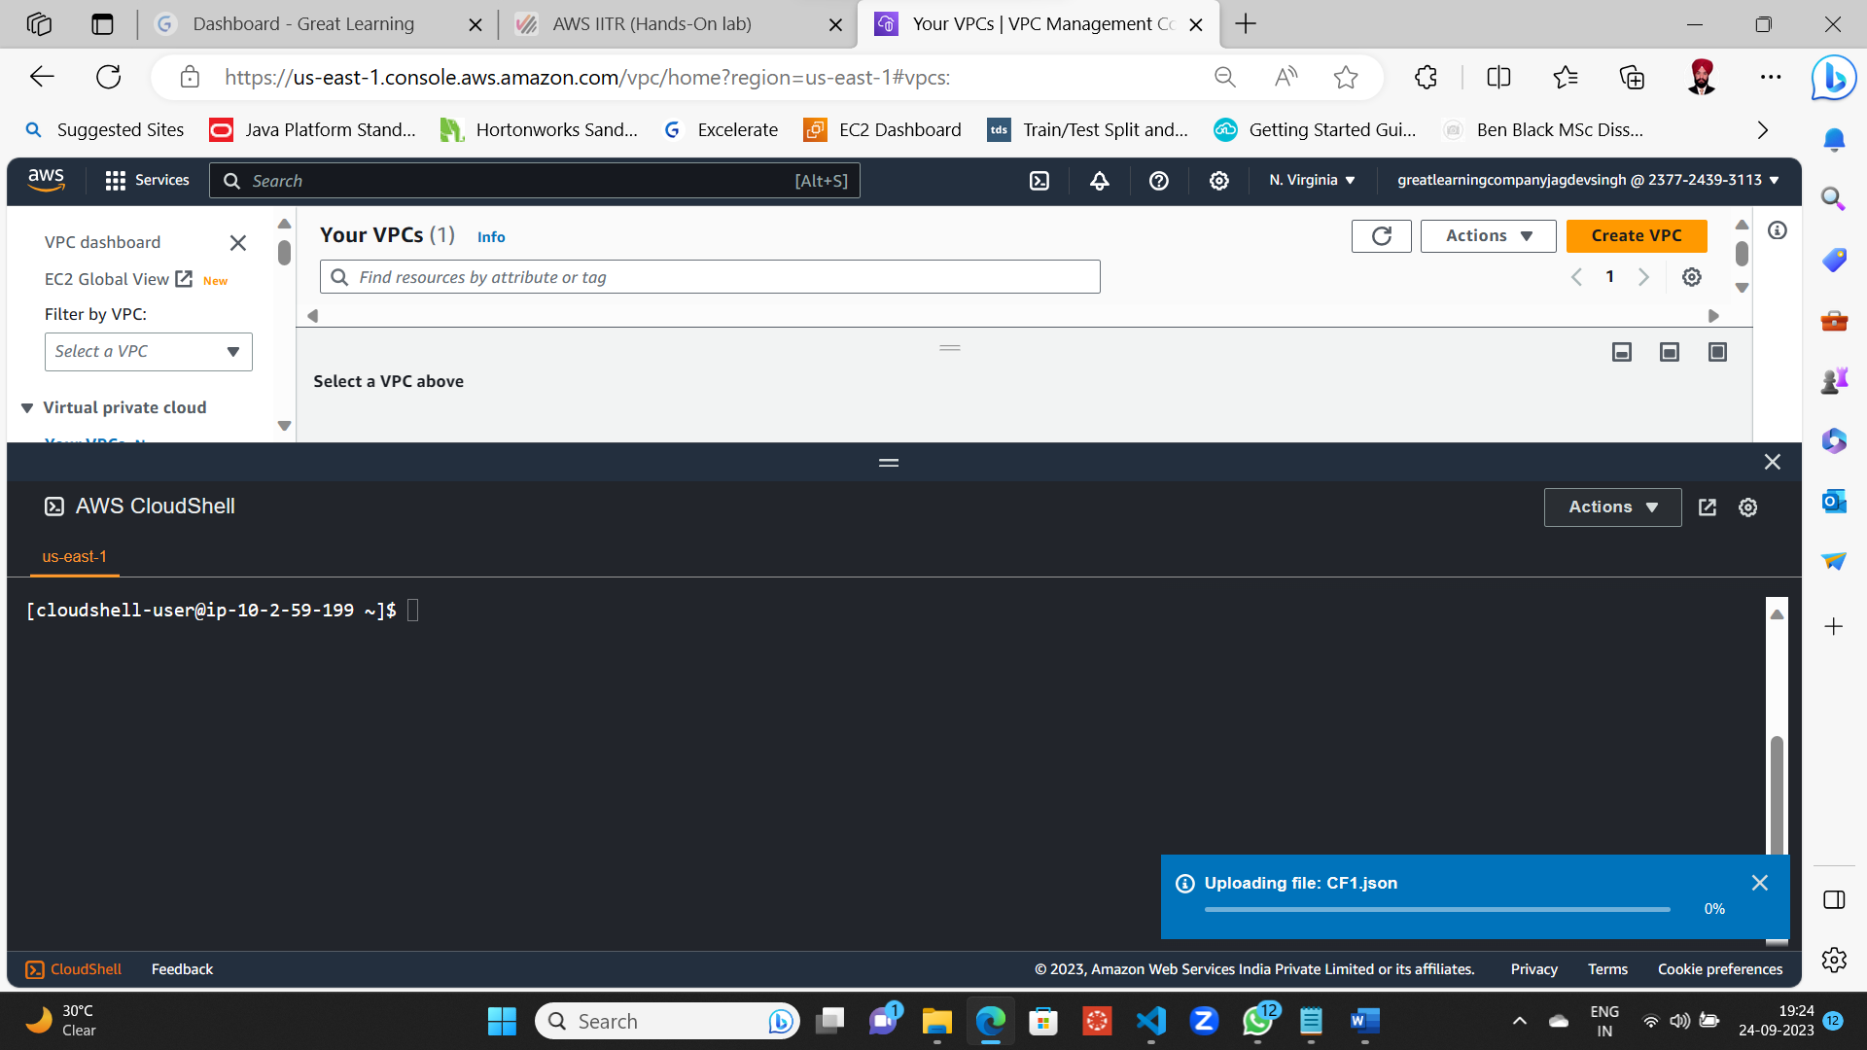

File 1 got uploaded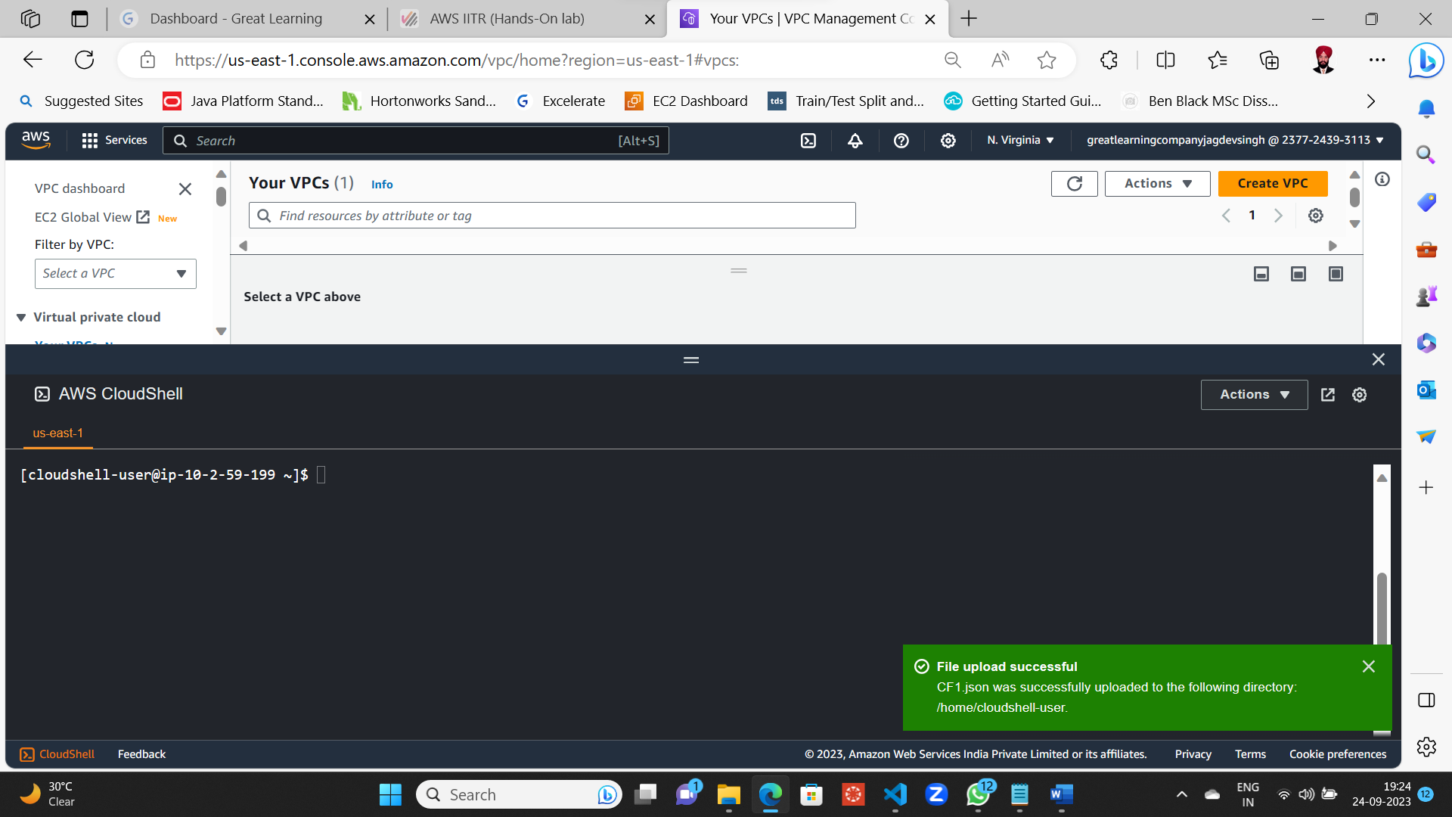

Uploading File 2

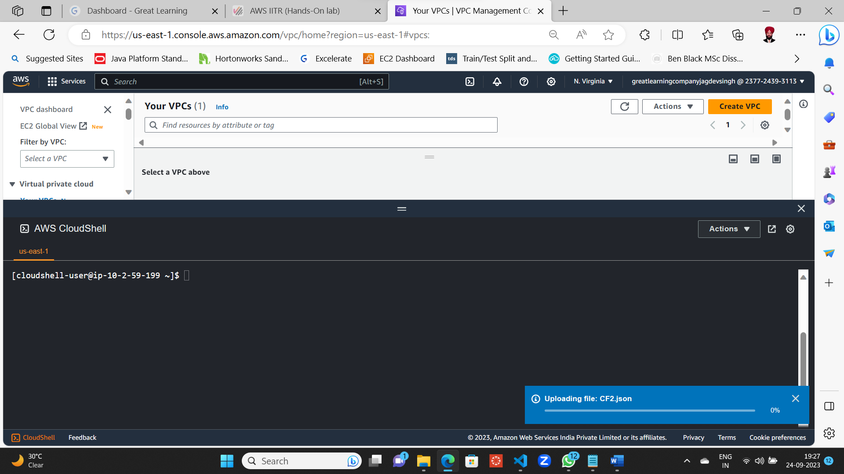

File 2 got uploaded

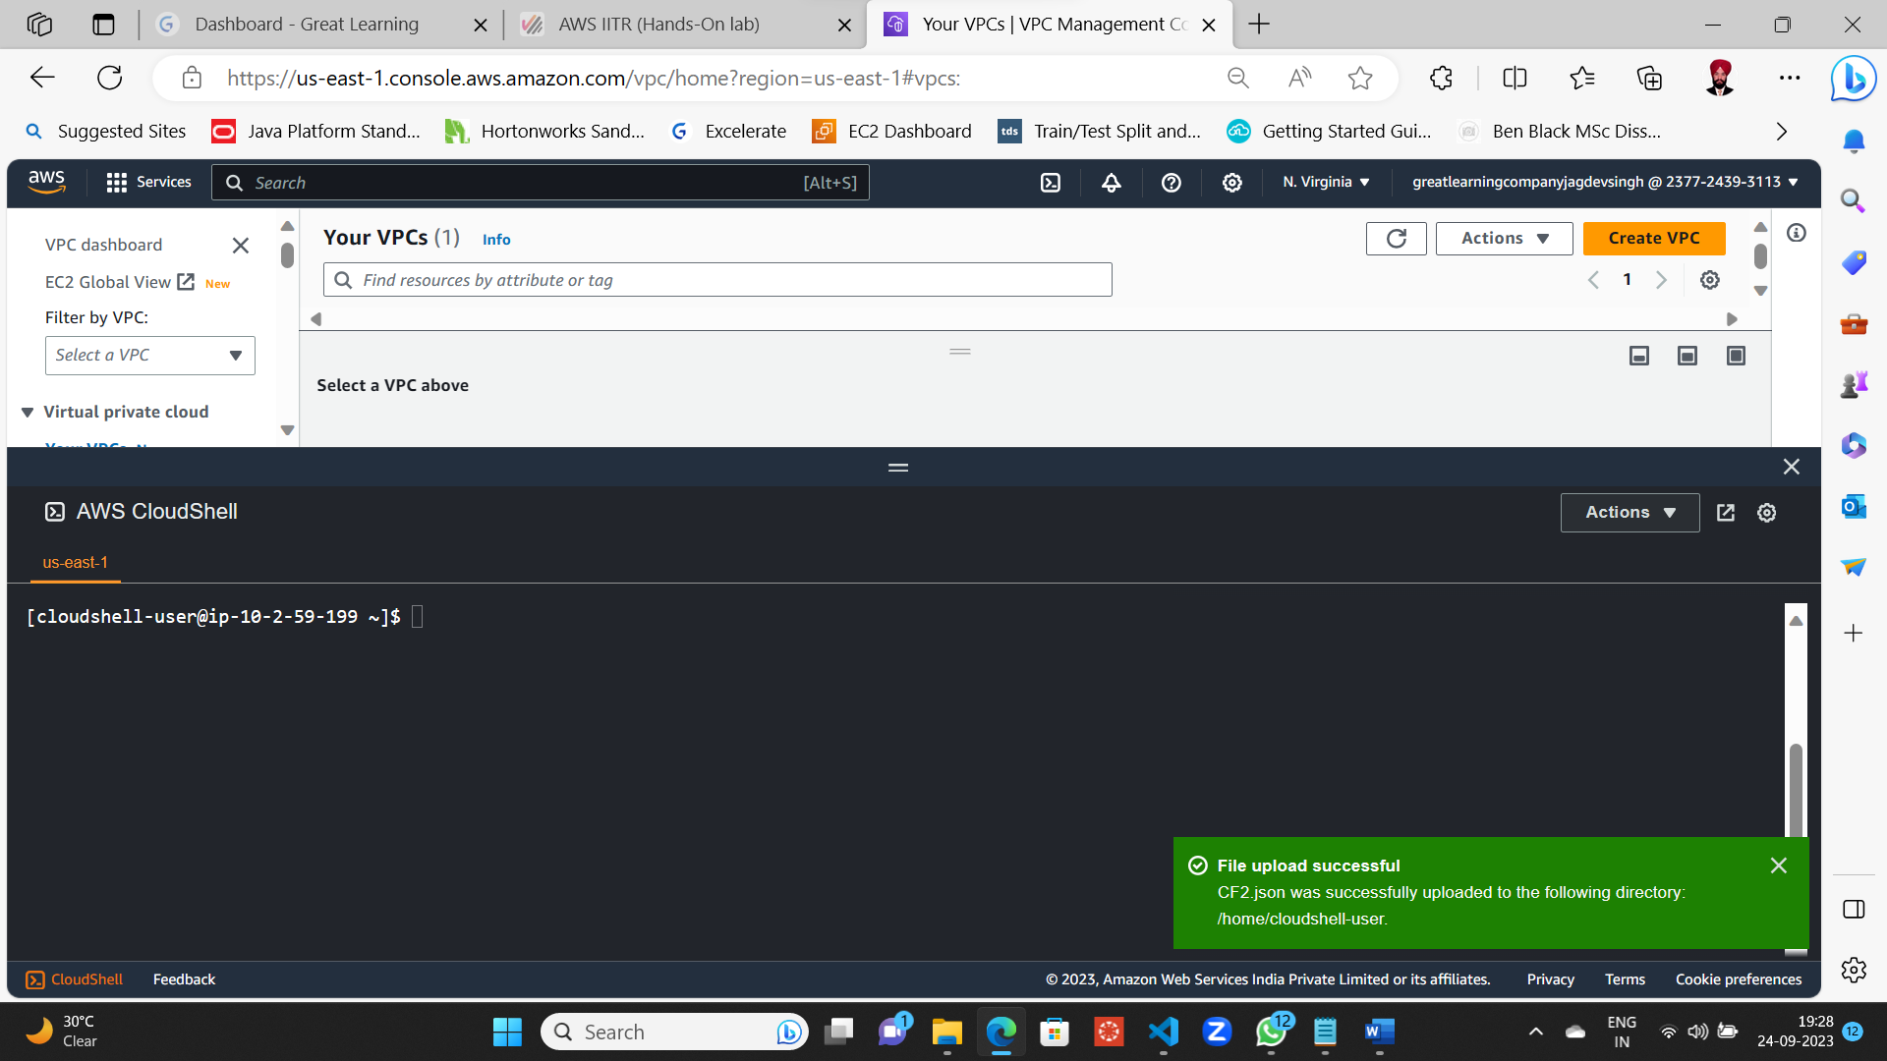

Running ls – al command to make sure the files are present in AWS Cloud Shell Terminal

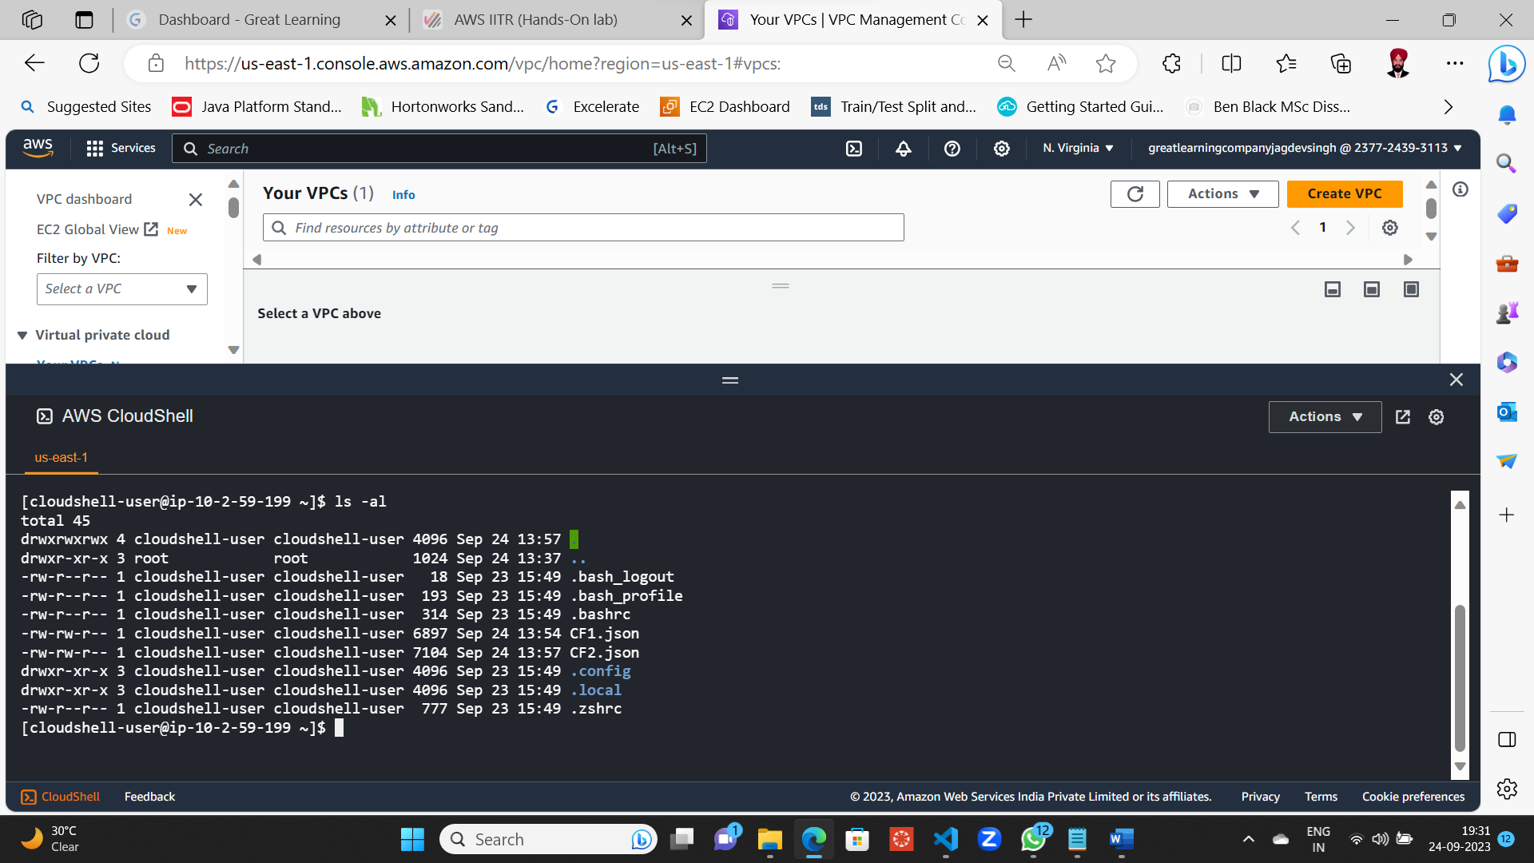

Checking for the Stack if any existing in Cloud Formation / Stack in AWS Console

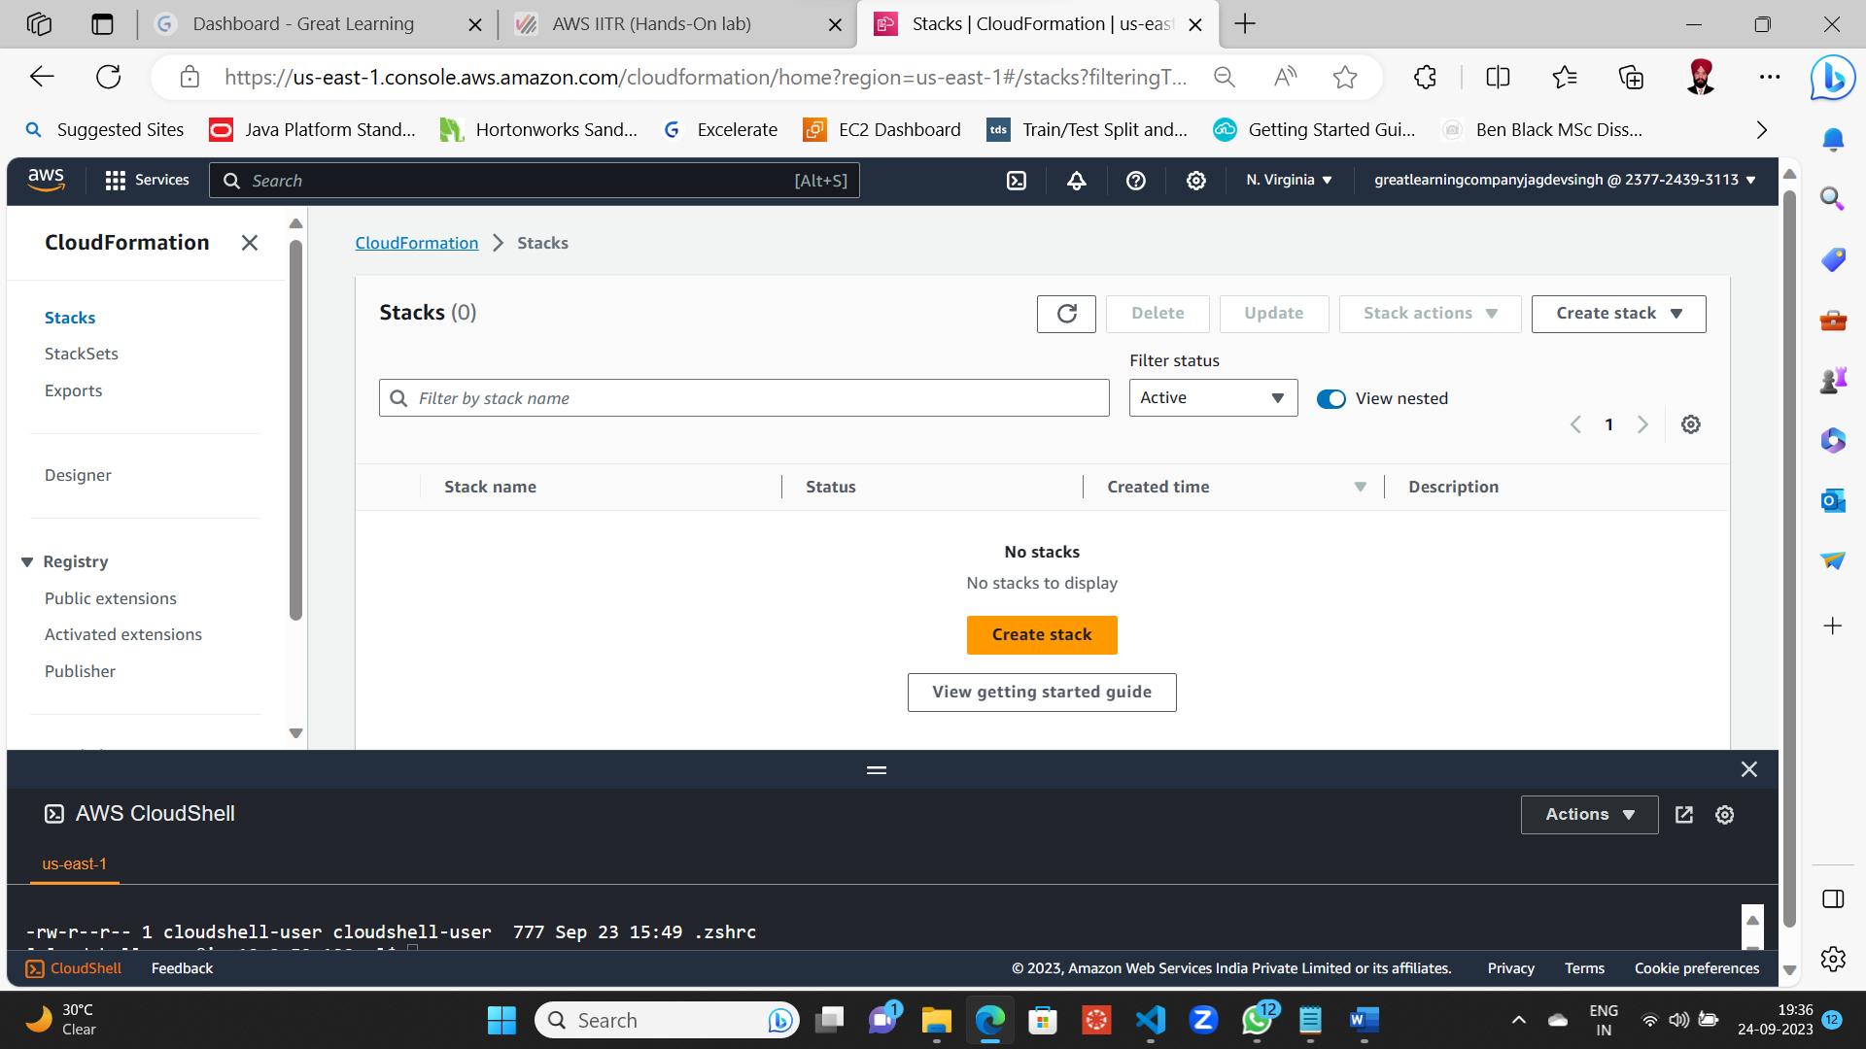

Status: No Stacks

Running the Cloud Formation Command using CF1.json file at AWS Cloud Shell Terminal

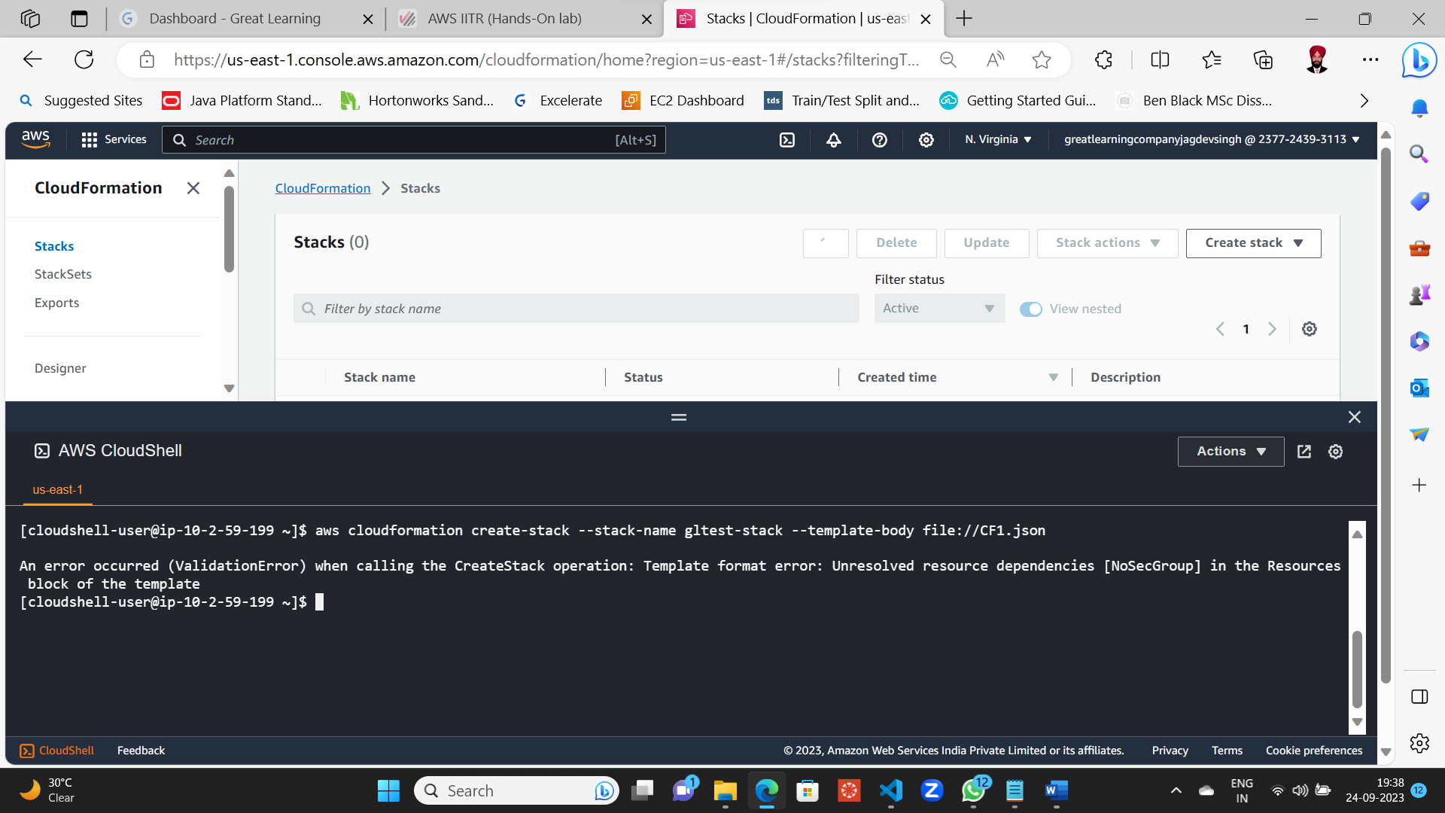

Status : Validation Error

Cause as mentioned in Problem Statement File

The security group for the Load Balancer has been set to “NoSecGroup” at line 183. However, there is no security group as such created in the JSON file.

If you navigate to line 32, you will see that the name of the security group created is “WebServerSecurityGroup”.

So, No Log is displayed for CF1 Stack creation process, and also output is without any URL being created.

Running the Cloud Formation Command using CF2.json file at AWS Cloud Shell Terminal, and checking the output of this command along with status check at Cloud Formation / Stack Console by refresh

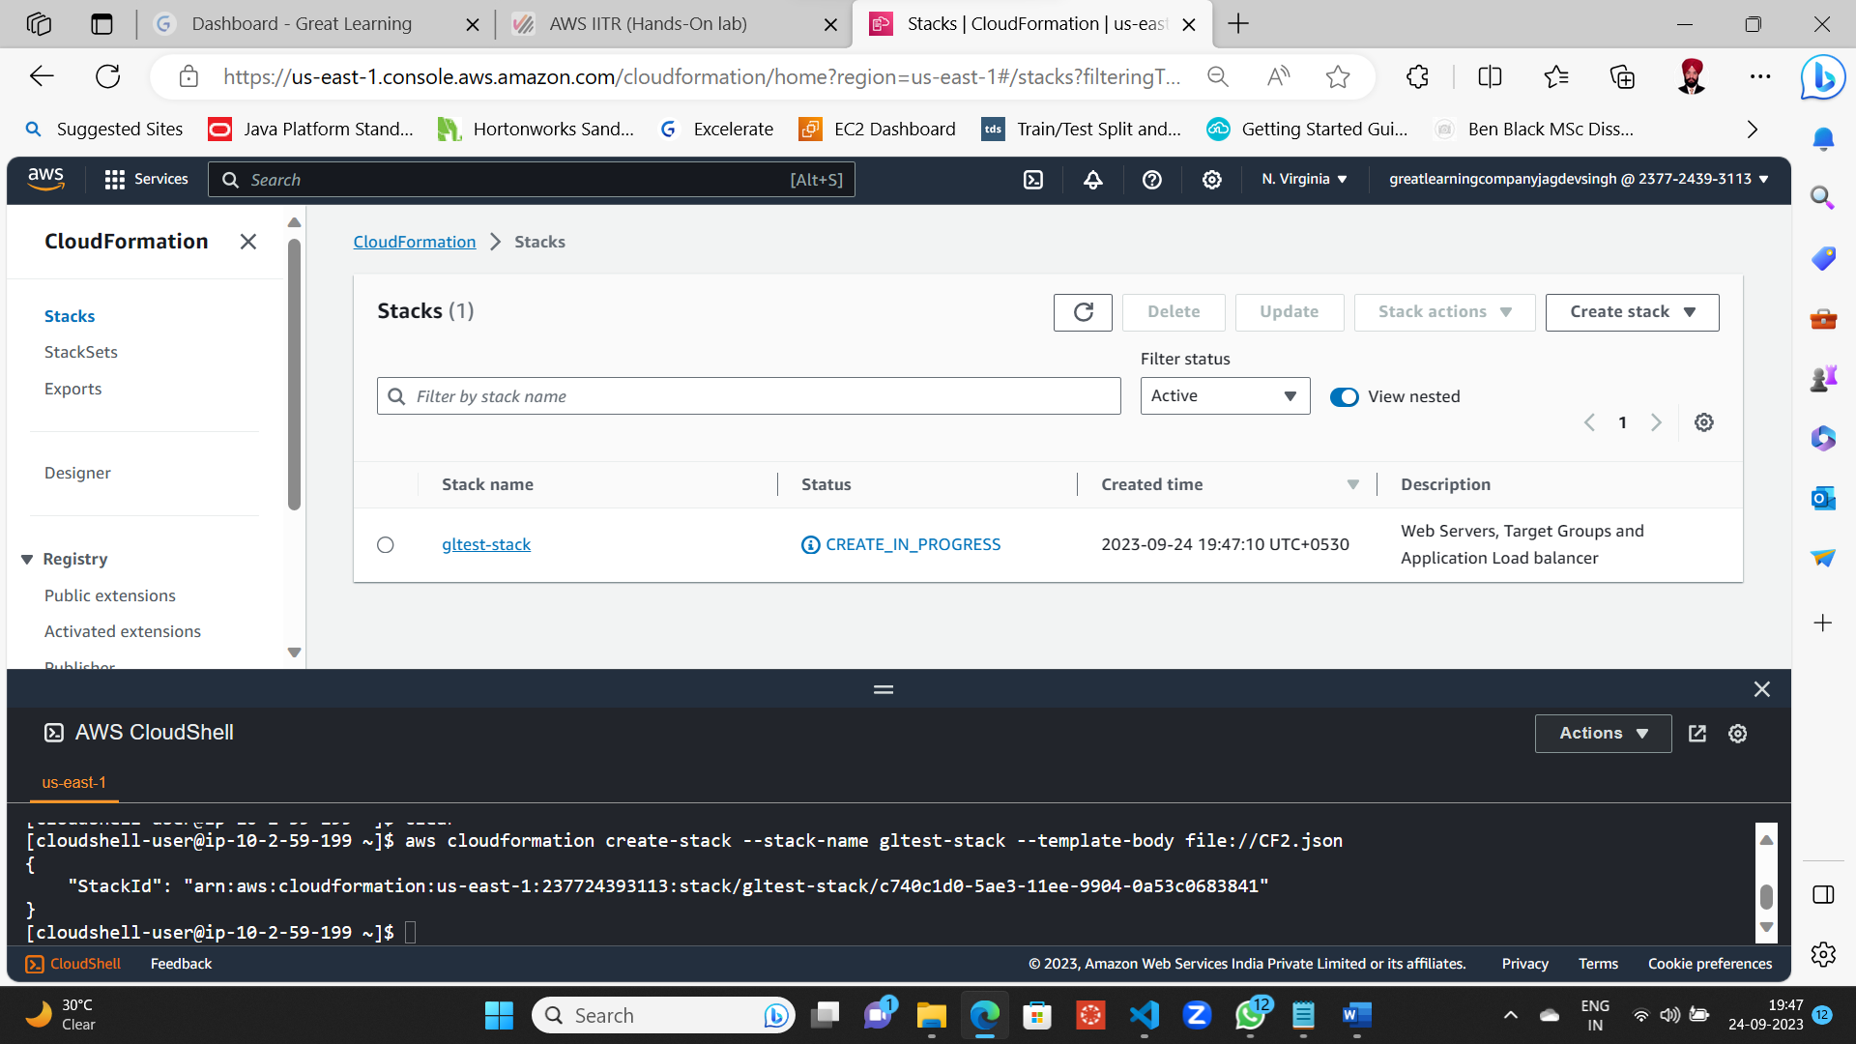

Status: command executed successfully with gltest-stack staus as create_in_progress

Log of CF2 in Events Tab

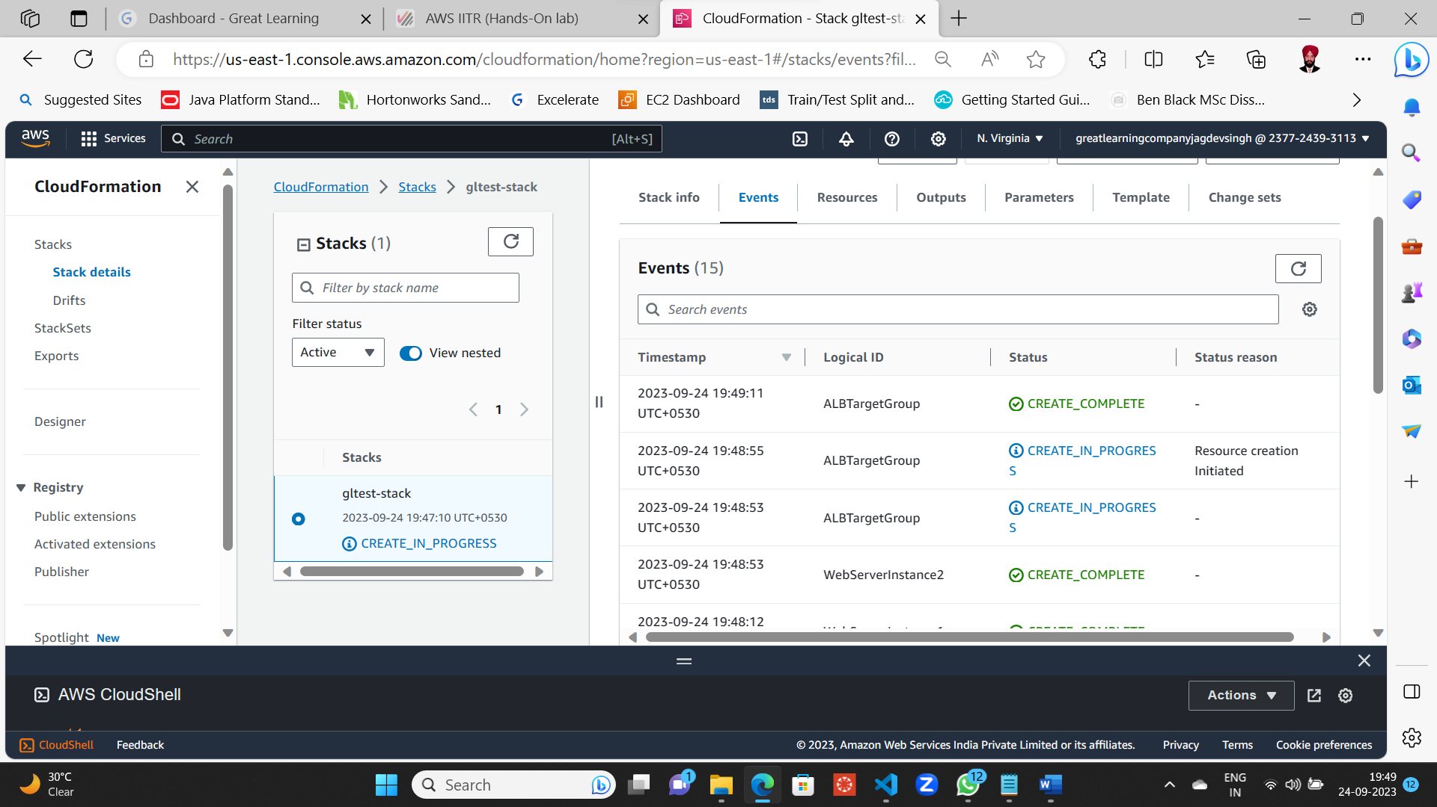

Log Snapshot for CF2.json Stack Creation

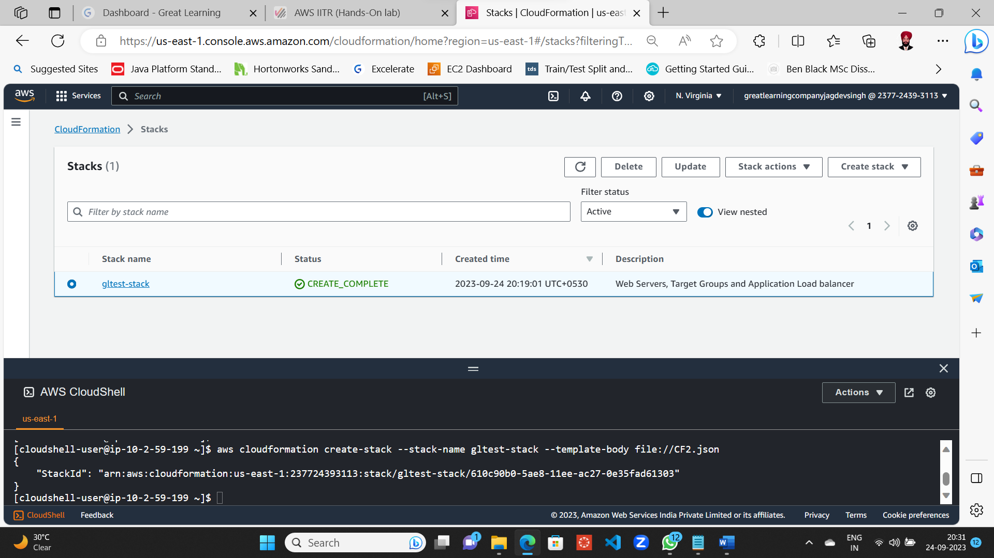

gltest-stack status as CREATE_COMPLETE

gltest-stack result at Output Tab of AWS Console

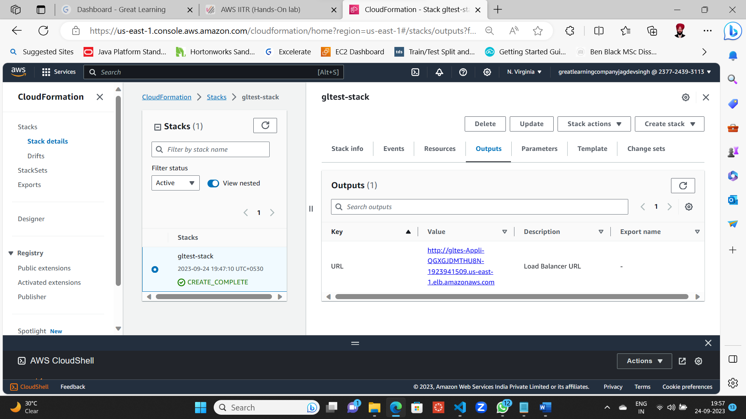

Status: URL got Created

Linux Apache Server got created successfully with message in new tab as

**Welcome to HTTP Server 1**

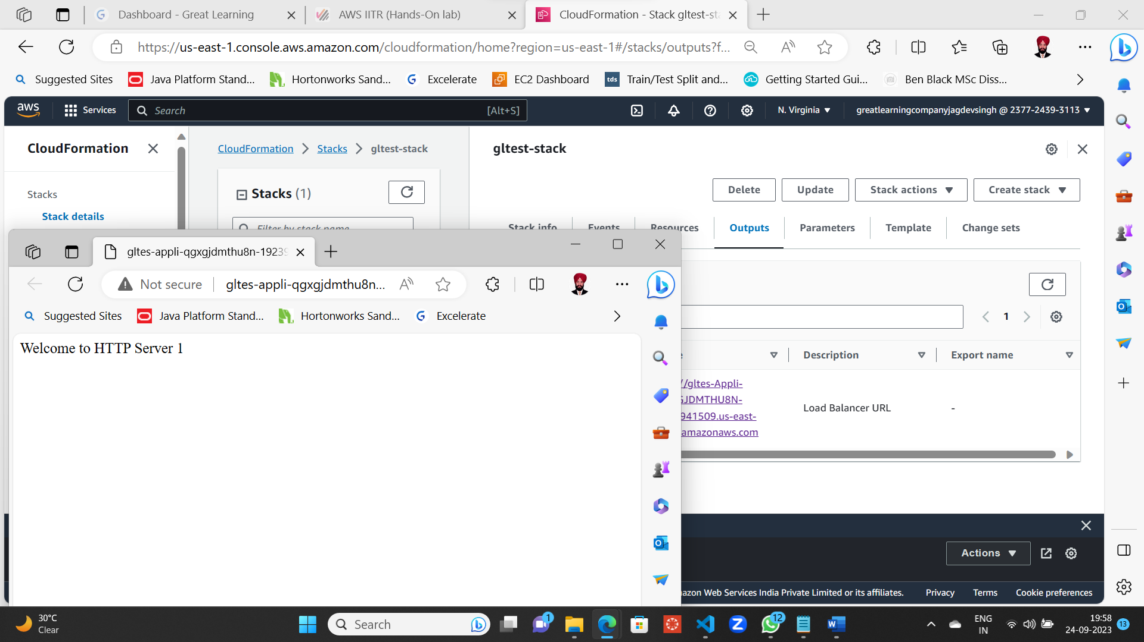

Refreshing the browser displays **Welcome to HTTP Server 2**

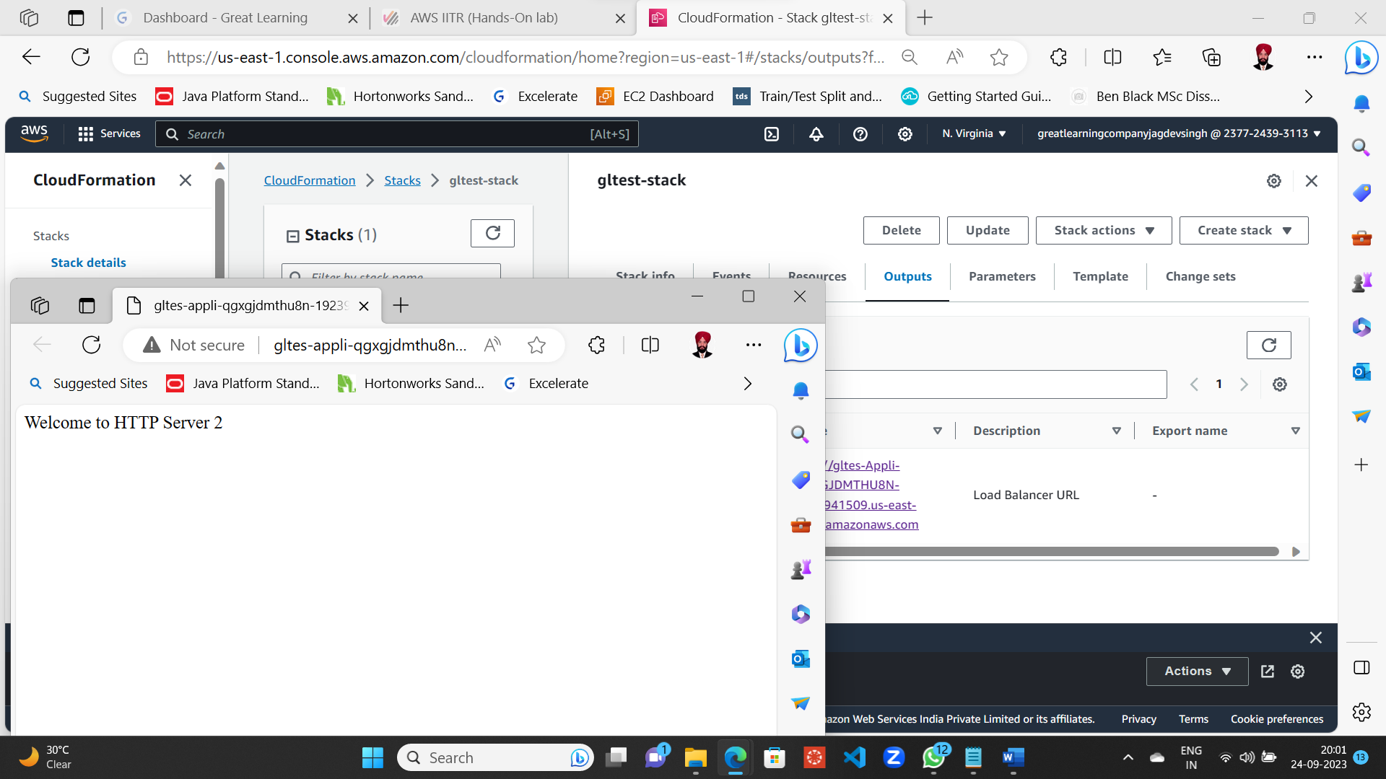

**II. Mandatory Snapshots**

1. **Log of stack creation using CF1.json 5 marks**

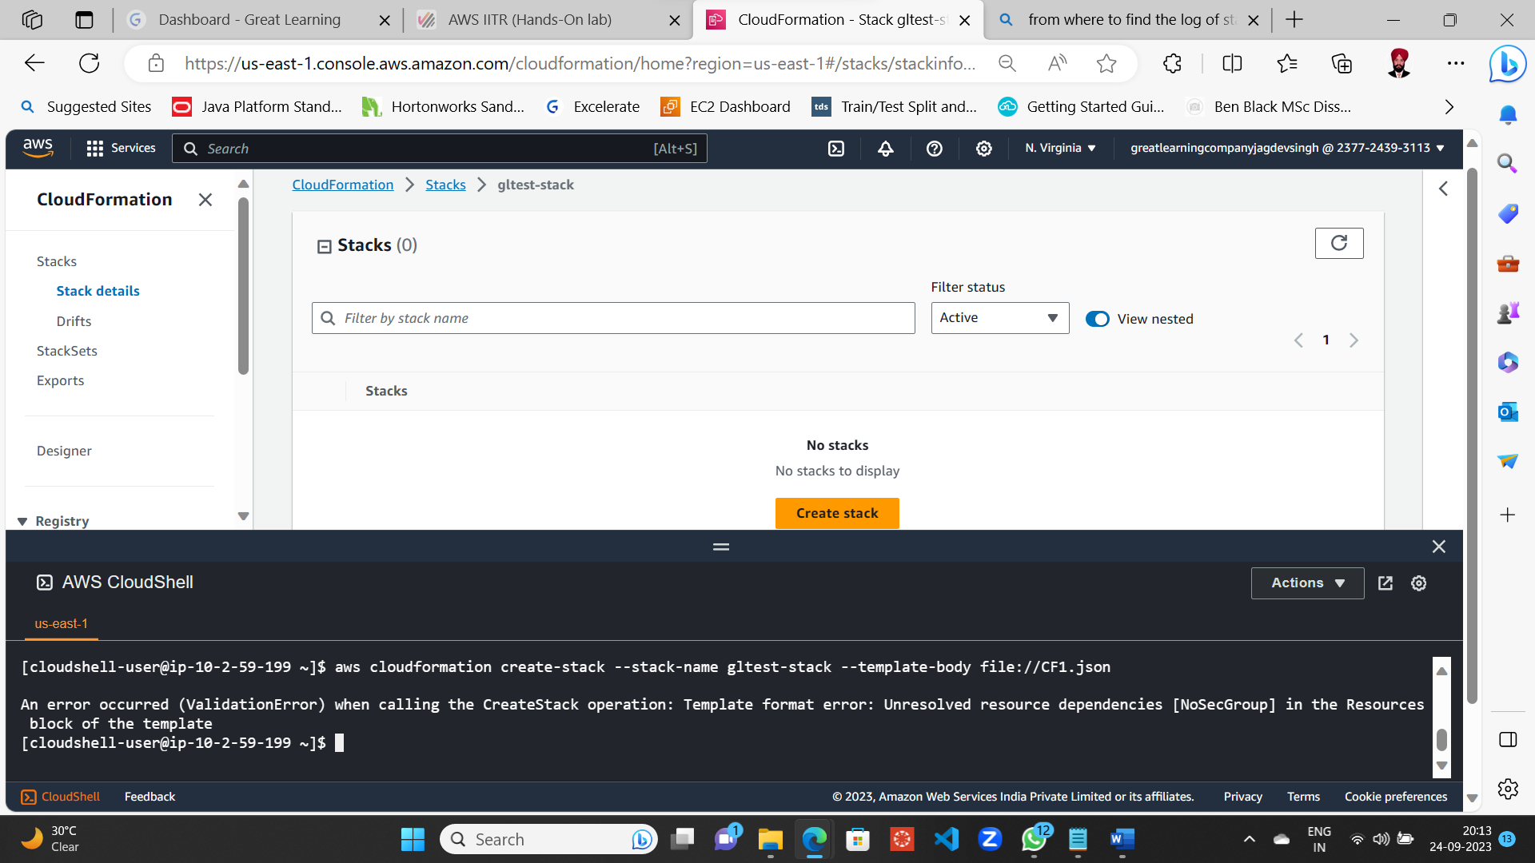

No stack formation (**Stacs(0)**) due to Validation Error and hence no logs for CF1.json’s Stack Events and Resources

1. **Error message when using CF1.json 5 marks**

**Separate Snapshot**

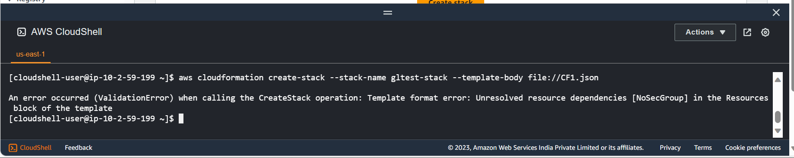

**Error Snapshot with Login ID in the top right corner**

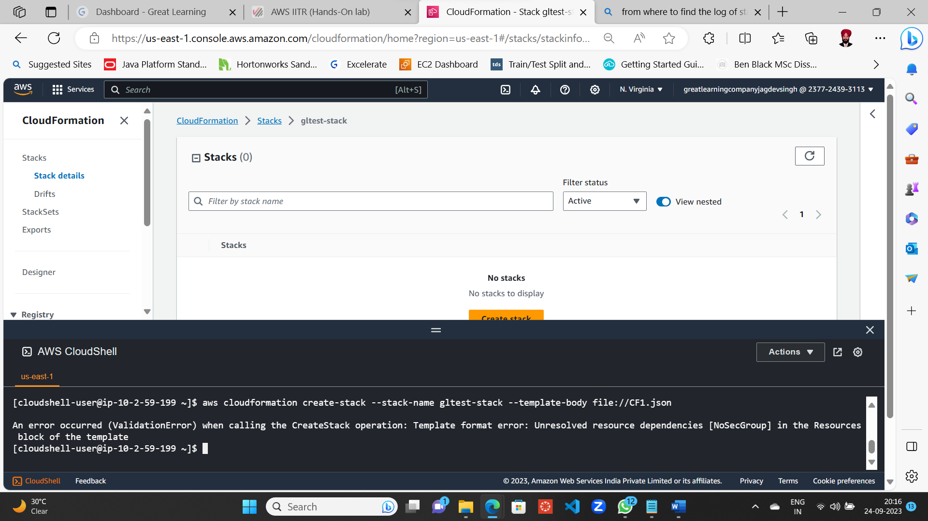

1. **Log of stack creation using CF2.json 5 marks**



**From Event Tab (Being created and in Progress)**

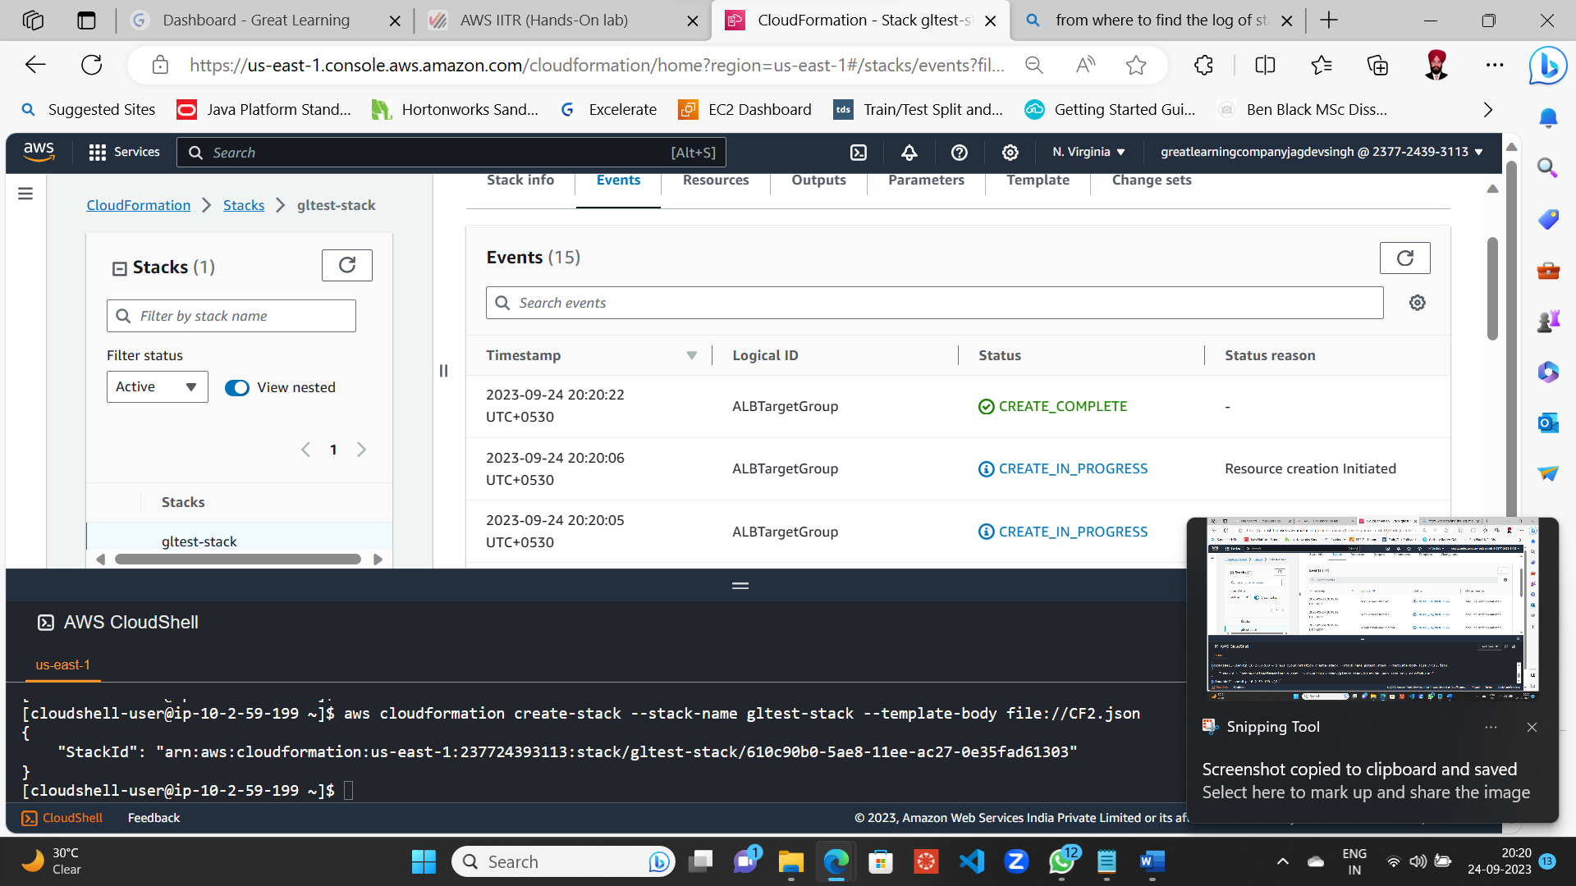

**From Resource Tab**

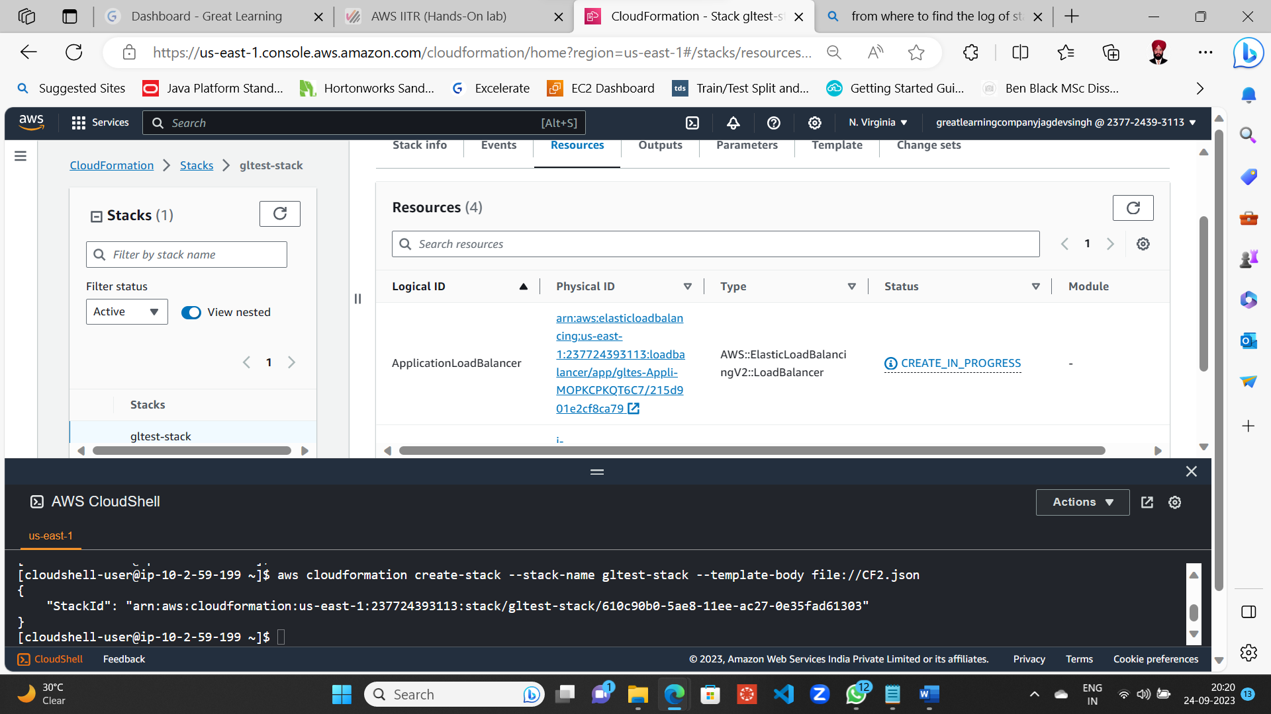

1. **URL in Web page 5 marks**

Linux Apache Server got created successfully with message displayed in new tab as

**Welcome to HTTP Server 1**



Refreshing the browser displays **Welcome to HTTP Server 2**



--------------x-------------